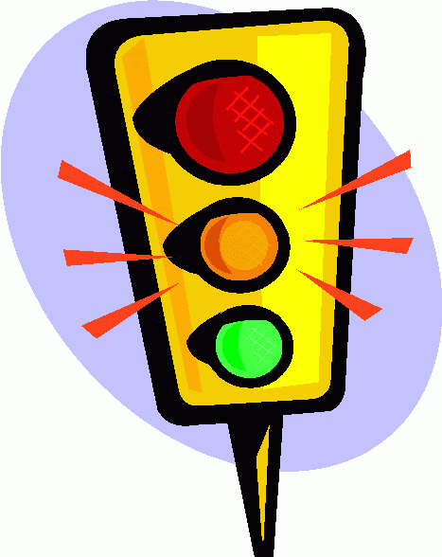 Stop, Slow Down, Go - Punctuation as the Stop Light of Grammar
Knowing when to use different forms of punctuation can get tricky, but there is a way to look at it that will help you in the future. If we compare some of the different forms of punctuation to a stop light, it becomes easier to see where certain punctuation marks go.

Period - Red Light: You have to come to a complete stop using a period as the thought has come to an end
Semicolon - Yellow Light: Slow down, the thought is not completely finished, but it requires you to break it up and slow the reading down. These are best used when linking two independent clauses without the use of a conjunction.
Comma - Green Light: Continue on with the reading, as a comma will indicate a list or a continuation of thoughts in the sentence, where you don't really need a complete pause while reading. Commas link adjectives that describe a noun, and they can also link independent clauses as effectively as a period
Colon - Blinking Red/ Yellow: A list is coming up and you only need to stop long enough to read it before continuing on. A colon marks a discontinuity in a sentence with more force than a comma or semicolon

North American pets are the most pampered in the world The dog is the most popular of all pets People own
dogs for three main reasons companionship security and friendship Dogs are good companions for people
For example older people often keep a small dog when children have moved away they will talk to the dog and
the dog will always listen When the older person comes home the dog wags its tail and is glad to see them
Dogs are also great companions they are not only good companions but they also provide security Often a
dog will smell someone near a house and begin to bark This is very important when people are away at work
or the store
Commas: 6
Periods: 9
Semicolons: 2
Colons: 1

